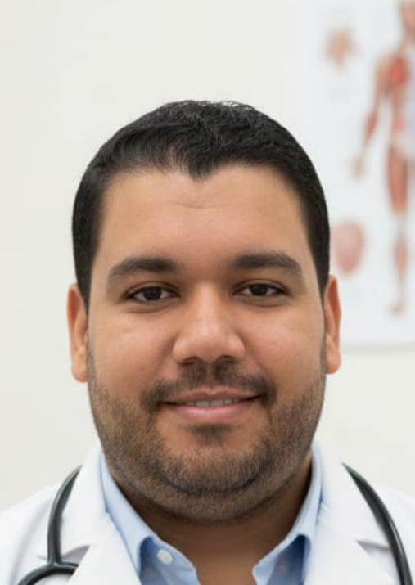
English CV
Dr. Ahmed Samy Ali Afifi
Ass.Lecturer of internal medicine and Gastroenterology unit
Faculty of Medicine, Benha University

- Personal data
Name (Arabic) | أحمد سامي علي عفيفي
Name (English) | Ahmed Samy Ali Afifi
Department | Internal medicine and Gastroenterology unit
College | Medicine
Academic degree | MD
Office Address | Benha
Mobile 1 | 01097950306
ID number | 29205251401934
Home phone
Email (university) | Docahmedsamy25@gmail.com  ahmed.samy@fmed.bu.edu.eg
- Education
Institution | Degree obtained | Year
Benha Faculty of Medicine | M.Sc. of Internal medicine | 2021
Benha Faculty of Medicine | M.B.B.Ch | 2015

General speciality | Internal medicine
Specific speciality | Gastroenterology

- Positions
 | Date  From - to | Organization | Country | Position | Role
1 | March 2016 to March 2017 | Benha Faculty of Medicine Hospital | Egypt | House Officer | Training in different medical clinical branches
2 | March 2017 to July 2017 | Egyptian Ministry of Health | Egypt | General practitioner
3 | July 2017 to  OCT 2020 | Benha Faculty of Medicine | Egypt | Resident doctor of Internal medicine
4 | DEC 2020 till now | Benha Faculty of Medicine | Egypt | Assistant Lecturer | Teaching  Research
5

- Publications
- QT Interval Prolongation as a predictor of short term Mortality In Patients With liver Cirrhosis and Acute Gastrointestinal Bleeding
Authors: | F.M.Khaliln, M.A.El Assal, A.M. Dabour, A.R. Mohamed, A.S. Afifi

- Membership of professional bodies :
Membership of Qalyubia Association Gastroenterology & Hepatologists
Membership in institute :
Member, Benha faculty of medicine
- Academic
Courses :
- International Publication of Scientific Research
- Development of Competitive Research Projects
- Educational Technology in Teaching and Learning
- Assessment and Evaluation Systems
- Website Administration and Management
- Academic Guidance and Advising
- Professional Ethics and Code of Conduct
- Certified teacher preparation program
- Attended workshops and conferences:
Annual conference of internal medicine department 2018,2019,2021,2022,2023,2024,2025
Qaliobia internal medicine and diabetes annual conference 2023,2024,2025
Case based learning workshop.

